Name Of The Student | Garima Modiyani
Internship Project Topic | TCS iON RIO-210: Build a Classification Model for Drug Trials Dataset
Name of the Organization | TCS iON
Name of the Industry Mentor | jignasha royala
Name of the Institute | Amity University

Date | Day | Hours Spent
10-11-2025 | Day-32 | 4 hours 40 minutes
Activities done during the day:

Learn about the visualization libraries Matplotlib and how to plot the figures.

Matplotlib:

Matplotlib is easy to use and an amazing visualizing library in Python. It is built on NumPy arrays and designed to work with the broader SciPy stack and consists of several plots like line, bar, scatter, histogram, etc.

Python plotting with Matplotlib from basics to advance with the help of a huge dataset containing information about different types of plots and their customizations.

Matplotlib take care of the creation of inbuilt defaults like Figure and Axes. Don’t worry about these terms we will study them in detail in the below section but let’s take a brief about these terms.

- Figure: This class is the top-level container for all the plots means it is the overall window or page on which everything is drawn. A figure object can be considered as a box-like container that can hold one or more axes.
- Axes: This class is the most basic and flexible component for creating sub-plots. You might confuse axes as the plural of axis but it is an individual plot or graph. A given figure may contain many axes but given axes can only be in one figure.

The following pip command in the command prompt to install Matplotlib.

pip install matplotlib

To verify that matplotlib is successfully installed on your system, execute the following command in the command prompt.

import matplotlib
matplotlib.__version__

If matplotlib is successfully installed, the version of matplotlib will be displayed.

Steps

- Import matplotlib.
- Set the figure size and adjust the padding between and around the subplots.
- Create random data points, x.
- Plot x using plot() method.
- To display the figure, use show() method.

Example:

from matplotlib import pyplot as plt
import numpy as np

plt.rcParams["figure.figsize"] = [7.50, 3.50]
plt.rcParams["figure.autolayout"] = True

x = np.random.rand(20)
plt.plot(x, '*-', color='red', markersize=10)

plt.show()

Output:

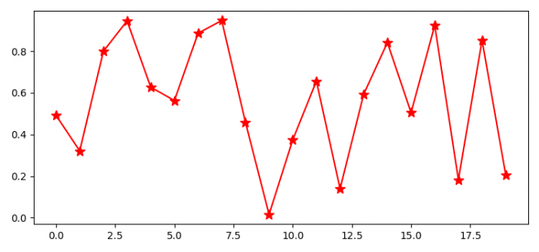
Reference:

https://matplotlib.org/2.0.2/users/pyplot_tutorial.html/

